IIS
https://www.youtube.com/watch?v=gzVNu4mzndQ
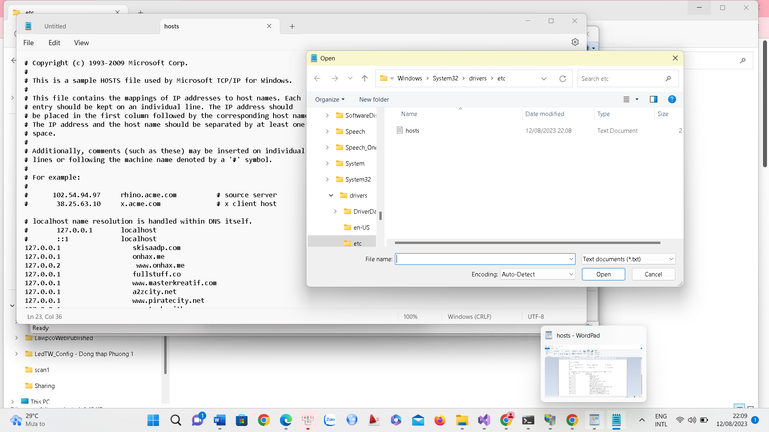

Cau hinh modem fpt tai nha
Name: admin
Pw: h289528

